

# Samsung Galaxy Tab S7+ 4G

## Type of device: Tablet

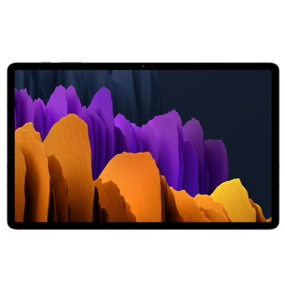

Actual Display Size : 12.4 inches

Operating System : Google Android

Version Number : Android 10

Network Capability : 3G,4G

Year of Release : 2020

Average Price : $1648 as of 22 June 2021

Internet Access : Wi-Fi and Mobile Broadband

## Accessibility Features:

### Cognitive

* Additional Instructions
* Copy and Paste
* Flicker Free Display
* GPS
* Photo Telephone List
* Screen Timeout Disabled
* Simple Instructions
* Simple Reminders
* Simplify Display

Voice Notes

### Hearing Impairment and Deaf

* Allows for sign language communication
* Bluetooth or Wi-Fi
* Closed Captioning
* Front Facing Camera
* Hearing Aid Microphone Coupling
* Hearing Aid Telecoil Coupling
* Text Messaging/SMS
* Vibrating Alerts - Adjustable
* Video Communications - Two-way

Visual Alerts - Incoming Calls

### Vision

* Accessibility APIs supported
* Battery Alert - Audible
* Bluetooth or Wi-Fi
* Braille Display Support
* Brightness Adjustable
* Dictation / Speech-to-Text
* High Contrast Mode
* Personalised Shortcuts
* Power Cue
* Screen Magnifier
* Screen Reader
* Text Size Adjustable
* Text Style Adjustable
* Voice Control /Personal Assistant

Voiced Menus

### Speech

* Allows for sign language communication
* Bluetooth or Wi-Fi
* Messaging Options - Email
* Messaging Options - IM
* Messaging Options - MMS
* Predictive Text

SMS Personalisation and Reuse

### Physical

* Bluetooth or Wi-Fi
* Dictation / Speech-to-Text
* Gesture Based Navigation
* Predictive Text
* Reduced hand movement option
* Speaker-phone option
* Stylus or Prosthetic Device support
* Switch control option
* Visible Focus Indicators
* Voice Control / Personal Assistant
* Voice Recognition for Accessing Features

Voice Recognition for Dialling

## How and where to get it from?

You can buy this phone from [Samsung](https://www.samsung.com/au/tablets/galaxy-tab-s/galaxy-tab-s7-plus-12-4-inch-mystic-silver-128gb-lte-sm-t975nzsaxsa/buy/), [Officeworks](https://www.officeworks.com.au/shop/officeworks/p/samsung-galaxy-tab-s7-4g-128gb-silver-s7pls4g128), [JB Hi-Fi](https://www.jbhifi.com.au/products/samsung-galaxy-tab-s7-12-4-4g-128gb-mystic-silver), [Mobileciti](https://www.mobileciti.com.au/samsung-galaxy-tab-s7-plus-6gb-128gb-wifi-4g-12-4-t975-mystic-silver), [Harvey Norman](https://www.harveynorman.com.au/samsung-galaxy-tab-s7-plus-4g-128gb-12-4-inch-tablet-mystic-silver.html), [The Good Guys](https://www.thegoodguys.com.au/samsung-galaxy-tab-s7-plus-4g-128gb---silver-sm-t975nzsaxsa), and other retailers.

## More information is available on:

[Samsung Galaxy Tab S7+ 4G Webpage](https://www.samsung.com/au/tablets/galaxy-tab-s/galaxy-tab-s7-plus-12-4-inch-mystic-silver-128gb-lte-sm-t975nzsaxsa/)

[Samsung Galaxy Tab S7+ 4G Support Webpage](https://www.samsung.com/au/support/model/SM-T975NZSAXSA/)

[Samsung Galaxy Tab S7+ 4G User Manual (PDF Download)](https://org.downloadcenter.samsung.com/downloadfile/ContentsFile.aspx?CDSite=UNI_AU&OriginYN=N&ModelType=N&ModelName=SM-T970&CttFileID=8099783&CDCttType=UM&VPath=UM%2F202104%2F20210423133442967%2FSM-T87X_T97X_UM_EU_RR_Eng_Rev.1.1_210304.pdf)